Exploratory Data Analysis OF FMRI data

Deepthy Rose Jose
IIT Madras
dracad@iitm.ac.in
am20s052@smail.iitm.ac.in

Abstract

Functional imaging (fMRI) is used to diagnose metabolic diseases and lesions on a finer scale (such as Alzheimer's disease and ADHD) and also for neurological and cognitive psychology research and building brain-computer interfaces. Exploratory Data Analysis (EDA) on fMRI using separate, unrelated large imaging dataset was utilized to learn feature templates derived from fMRI images as input.

Introduction
Human brain research is the study of the human brain, the central nervous system which is housed inside the skull. Since there are many aspects to this research and all individuals have different and unique brains, it is impossible to compare a human brain to another's in-depth.

Neuroimaging or brain imaging is the use of various techniques to either directly or indirectly image the structure, function, or pharmacology of the nervous system. It is a relatively new discipline within medicine, neuroscience, and psychology.

Neuroimaging
Neuroimaging is increasingly used by psychologists to make inferences about mental states and brain functioning. There are a number of techniques available including functional neuroimaging (fMRI), diffusion tensor imaging, electroencephalography (EEG), magnetoencephalography (MEG), transcranial magnetic stimulation and others. This has led to a new cross-disciplinary field, cognitive neuroimaging, which combines cognitive psychology with the emerging technology of functional neuroimaging.

Neuroimaging specialists look for measurable markers of behavior, such as electrical activity in the brain, to understand how human beings react in certain contexts. Neuroimaging is often used by psychologists to help diagnose psychiatric conditions such as depression and schizophrenia.

Neuroimaging falls into two broad categories:

- Structural imaging, which deals with the structure of the nervous system and the diagnosis of gross (large scale) intracranial disease (such as a tumor) and injury.

- Functional imaging, which is used to diagnose metabolic diseases and lesions on a finer scale (such as Alzheimer's disease, ADHD) and also for neurological and cognitive psychology research and building brain-computer interfaces.

1.2 Functional Magnetic Resonance Imaging (fMRI)

Functional magnetic resonance imaging (fMRI) relies on the paramagnetic properties of oxygenated and deoxygenated hemoglobin to see images of changing blood flow in the brain associated with neural activity. This allows images to be generated that reflect which brain structures are activated (and how) during the performance of different tasks or at resting state. According to the oxygenation hypothesis, changes in oxygen usage in regional cerebral blood flow during cognitive or behavioral activity can be associated with the regional neurons as being directly related to the cognitive or behavioral tasks being attended.

A functional MRI (fMRI) of the brain is useful for people who might have to undergo brain surgery. An fMRI can pinpoint areas of the brain responsible for speech and language, and body movement. It does this by measuring metabolic changes that take place in your brain when you perform certain tasks. Most fMRI scanners allow subjects to be presented with different visual images, sounds and touch stimuli, and to make different actions such as pressing a button or moving a joystick. Consequently, fMRI can be used to reveal brain structures and processes associated with perception, thought and action. The resolution of fMRI is about 2-3 millimeters at present, limited by the spatial spread of the hemodynamic response to neural activity. It has largely superseded PET for the study of brain activation patterns. PET, however, retains the significant advantage of being able to identify specific brain receptors (or transporters) associated with particular neurotransmitters through its ability to image radiolabeled receptor "ligands" (receptor ligands are any chemicals that stick to receptors).

Methodology
An unbiased strategy was utilized to obtain the provided features. This means that a separate, unrelated large imaging dataset was utilized to learn feature templates. Then, these templates were "projected" onto the original imaging data of each subject used for this competition using spatially constrained independent component analysis (scICA) via group information guided ICA (GIG-ICA).

The first set of features are source-based morphometry (SBM) loadings. These are subject-level weights from a group-level ICA decomposition of gray matter concentration maps from structural MRI (sMRI) scans.

The second set are static functional network connectivity (FNC) matrices. These are the subject-level cross-correlation values among 53 component time courses estimated from GIG-ICA of resting state functional MRI (fMRI).

The third set of features are the component spatial maps (SM). These are the subject-level 3D images of 53 spatial networks estimated from GIG-ICA of resting state functional MRI (fMRI).

Data Format of Medical Images
The [. nii] file type is primarily associated with NIfTI-1 Data Format by Neuroimaging Informatics Technology Initiative. NIfTI-1 is adapted from the widely used ANALYZE 7.5 file format. NIfTI-1 uses the empty space in the ANALYZE 7.5 header to add several new features.
It is read using Nilearn python module.

Nilearn is a Python module for fast and easy statistical learning on NeuroImaging data. It leverages the scikit-learn Python toolbox for multivariate statistics with applications such as predictive modelling, classification, decoding, or connectivity analysis.

In nilearn, we often use the term “niimg” as abbreviation that denotes either a file name or a NiftiImage object. Niimgs can be 3D or 4D. A 4D niimg may for instance represent a time series of 3D images.

Brain Image Visualization
Any three random images is taken and the plot is visualized.
.

Plotting Statistical Map
Statistical parametric mapping or SPM is a statistical technique for examining differences in brain activity recorded during functional neuroimaging experiments. The measurement technique depends on the imaging technology (e.g., fMRI and PET). The scanner produces a 'map' of the area that is represented as voxels. Each voxel represents the activity of a specific volume in three-dimensional space. The exact size of a voxel varies depending on the technology. fMRI voxels typically represent a volume of 27 mm3 (a cube with 3mm length sides).

Parametric statistical models are assumed at each voxel, using the general linear model to describe the data variability in terms of experimental and confounding effects, with residual variability. Hypotheses expressed in terms of the model parameters are assessed at each voxel with univariate statistics.

Analyses may examine differences over time (i.e. correlations between a task variable and brain activity in a certain area) using linear convolution models of how the measured signal is caused by underlying changes in neural activity.

Because many statistical tests are conducted, adjustments have to be made to control for type I errors (false positives) potentially caused by the comparison of levels of activity over many voxels. A type I error would result in falsely assessing background brain activity as related to the task. Adjustments are made based on the number of resels in the image and the theory of continuous random fields in order to set a new criterion for statistical significance that adjusts for the problem of multiple comparisons.

Glass Brain Visualization
Glass Brain is a tool that maps the electrical activity of your brain in realtime.The anatomically realistic 3D brain will show realtime data from electroencephalographic (EEG) signals taken from a specially-designed EEG cap.This data is mapped to the source of that electrical activity, i.e. the specific part of the brain. The underlying brain model is generated through MRI scans so that the EEG data is accurately mapped to an individual's brain model.

Different colours are given to the different signal frequency bands to create a beautiful interactive artwork that seems to crackle with energy, showing how information is transferred (or at least estimated to do so) between different regions of the brain.

Plotting Echo-Planar Imaging
In Echo-Planar Imaging (EPI)-based Magnetic Resonance Imaging (MRI), inter-subject registration typically uses the subject's T1-weighted (T1w) anatomical image to learn deformations of the subject's brain onto a template. The estimated deformation fields are then applied to the subject's EPI scans (functional or diffusion-weighted images) to warp the latter to a template space.

Plotting Anatomical Image
Main Idea of this visualization technique is to provide the anatomical picture of the brain. Due to the measurement procedures, BOLD images usually have a relatively low resolution, as you want to squeeze in as many data-points along time as possible.

Plotting ROI
When mapping brain connectivities, ROIs provide the structural substrates for measuring connectivities within individual brains and for pooling data across populations. Thus, identification of reliable, reproducible and accurate ROIs is critically important for the success of brain connectivity mapping.

EDA
In statistics, exploratory data analysis is an approach of analyzing data sets to summarize their main characteristics, often using statistical graphics and other data visualization methods. A statistical model can be used or not, but primarily EDA is for seeing what the data can tell us beyond the formal modeling or hypothesis testing task. We will be using the above generated data to analyze, check missing values and analyze the correlation.

Data Cleaning and Preparation
Handling missing values is an essential part of data cleaning and preparation process because almost all data in real life comes with some missing values.

Missing values need to be handled because they reduce the quality for any of our performance metric. It can also lead to wrong prediction or classification and can also cause a high bias for any given model being used. The missing values are filled with test statistic (mean, median, mode).

Feature Correlation
Interpreting the Heatmap - the first thing to note is that only the numeric features are compared, as it is obvious that we cannot correlate between alphabets or strings. Before understanding the plot, let us see what exactly correlation is.

POSITIVE CORRELATION: If an increase in feature A leads to increase in feature B, then they are positively correlated. A value 1 means perfect positive correlation.

NEGATIVE CORRELATION: If an increase in feature A leads to decrease in feature B, then they are negatively correlated. A value -1 means perfect negative correlation.

Now lets say that two features are highly or perfectly correlated, so the increase in one leads to increase in the other. This means that both the features are containing highly similar information and there is very little or no variance in information. This is known as Multicollinearity as both of them contains almost the same information.

While making or training models, we should try to eliminate redundant features as it reduces training time and many such advantages.

Illustrations, graphs, and photographs

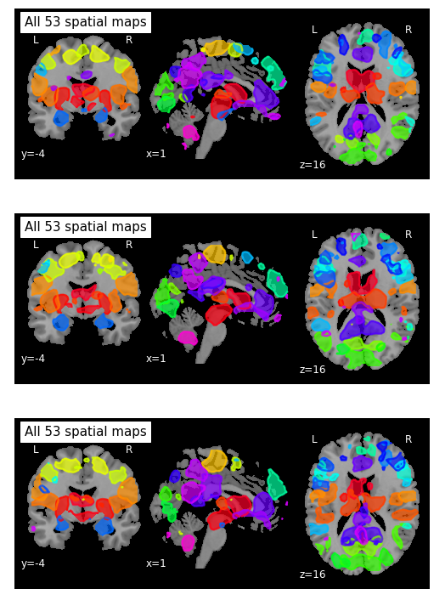
Figure 1. 4D probabilistic atlas maps

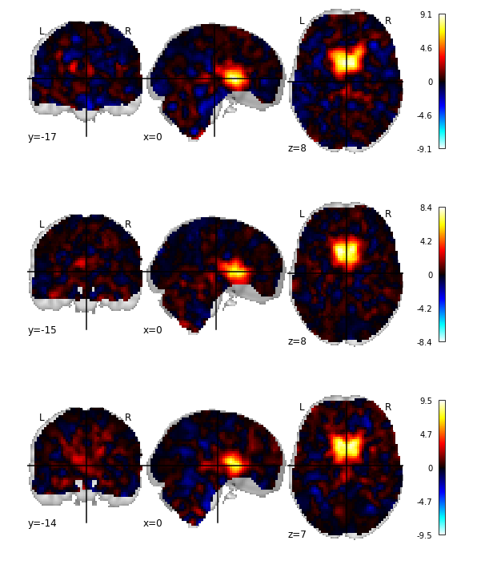

Figure 2. Statistical Parametric Mapping

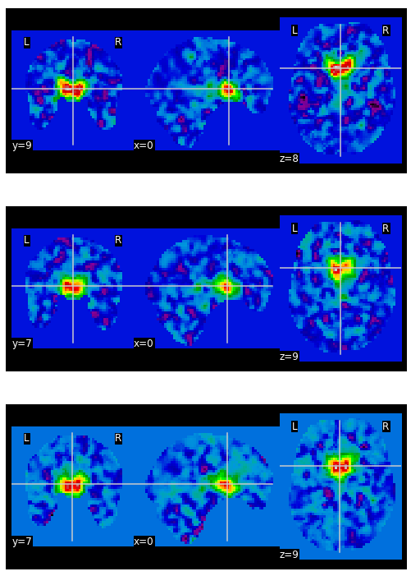
Figure 3. Echo- Planar Imaging (EPI)

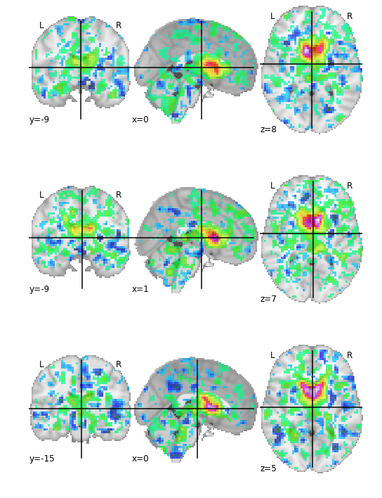
Figure 4. ROI of Brain connectivity mapping

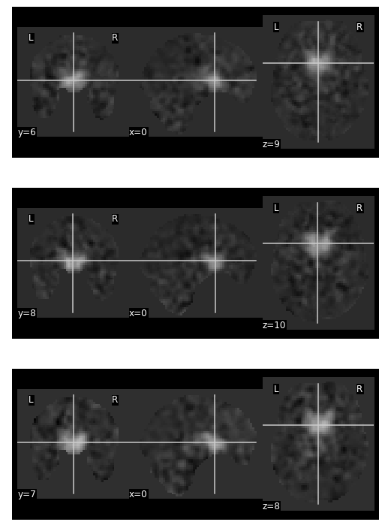
Figure 5. BOLD Anatomical image

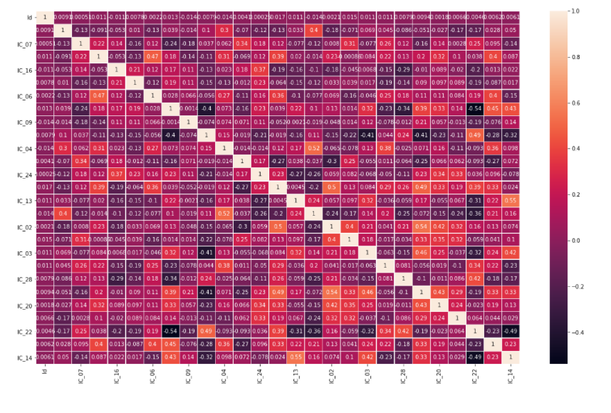
Figure 6. Correlation between features using heatmap

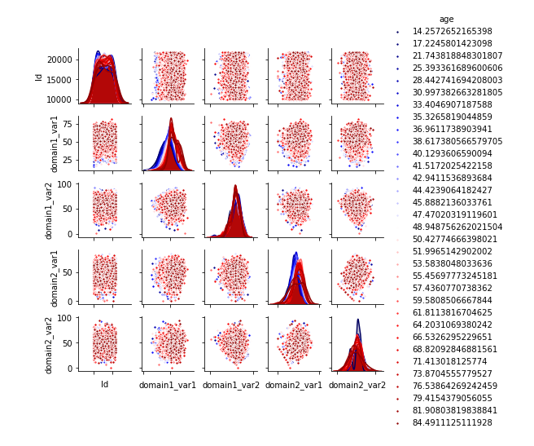
Figure 7. Pair plotting for assessment between age and fmri

Conclusion and Results

EDA allows us to predict age and assessment values from the given two domains. The EDA data facilitated multivariate analysis of the fMRI data using sCICA. It enabled observation of brain regions additionally implicated in within‐participant differences in behavior, representing a novel way in which EDA data can be used to interpret fMRI data.. The basic concept of ICA is to extract independent components from data without any prior hypothesis. In this project, using the data we predict age(guesstimate values)

The future scope of this project is for real time simulation of these datas via mediums such as VR or AR and it will help in predicating disorders of user based on simultaneous fmri taken

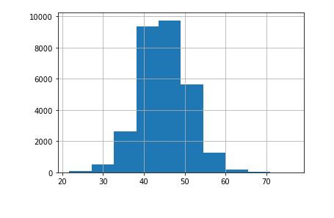
Figure 8. Guesstimate prediction of age based on fmri activity levels of feature templates.
.

References
- Borg G( 1985): Psychophysical studies of effort and exertion: Some historical, theoretical and empirical aspects In: Borg G, Ottoson D, editors. The Perception of Exertion in Physical Work. Stockholm: Macmillan; pp. 3–12. Proceedings of an International Symposium. [Google Scholar]
- Cheng DT, Knight DC, Smith, CN , Stein, EA , Helmstetter, FJ ( 2003): Functional MRI of human amygdala activity during Pavlovian fear conditioning: Stimulus processing versus response expression. Behav Neurosci 117: 3–10. [PubMed] [Google Scholar]
- Cox RW ( 1996): AFNI: Software for analysis and visualization of functional magnetic resonance neuroimages. Computers Biomed Res 29: 162–173. [PubMed] [Google Scholar]
- Critchley HD, Elliott R, Mathias CJ, Dolan RJ ( 2000): Neural activity relating to generation and representation of galvanic skin conductance responses: A functional magnetic resonance imaging study. J Neurosci 20: 3033–3040. [PMC free article] [PubMed] [Google Scholar]
- Critchley HD, Melmed RN, Featherstone E, Mathias CJ, Dolan RJ, ( 2001): Brain activity during biofeedback relaxation: A functional neuroimaging investigation. Brain 124(Pt 5): 1003–1012. [PubMed] [Google Scholar]
- Giannoylis I, Nelson A, Staines WR, Mcllroy WE, ( 2003): Effects of perceived effort on cortical activation during motor task performance measured using fMRI. Soc Neurosci Abstr 29. Washington, DC. [Google Scholar]
- Glover GH, Thomason ME( 2004): Improved combination of spiral‐in/out images for BOLD fMRI. Magn Reson Med 51: 863–868. [PubMed] [Google Scholar]
- Grafton ST, Hazeltine E, Ivry RB, ( 2002): Motor sequence learning with the nondominant left hand. A PET functional imaging study. Exp Brain Res 146: 369–378. [PubMed] [Google Scholar]
- Jenkins IH, Brooks DJ, Nixon PD, Frackowiak RS, Passingham RE, ( 1994): Motor sequence learning: A study with positron emission tomography. J Neurosci 14: 3775–3790. [PMC free article] [PubMed] [Google Scholar]
- Johansen‐Berg H, Christensen V, Woolrich M, Matthews PM, ( 2000): Attention to touch modulates activity in both primary and secondary somatosensory areas. Neuroreport 11: 1237–1241. [PubMed] [Google Scholar]
- Johansen‐Berg H, Dawes H, Guy C, Smith SM, Wade DT, Matthews PM( 2002). Correlation between motor improvements and altered fMRI activity after rehabilitative therapy. Brain 125(Pt 12): 2731–2742. [PubMed] [Google Scholar]
- Knight DC, Nguyen HT, Bandettini PA, ( 2005): The role of the human amygdala in the production of conditioned fear responses. Neuroimage 26: 1193–1200. [PubMed] [Google Scholar]
- LaBar KS, Gatenby JC, Gore JC, LeDoux JE, Phelps EA, ( 1998): Human amygdala activation during conditioned fear acquisition and extinction: A mixed‐trial fMRI study. Neuron 20: 937–945. [PubMed] [Google Scholar]
- Lim CL, Seto‐Poon M, Clouston PD, Morris JG ( 2003): Sudomotor nerve conduction velocity and central processing time of the skin conductance response. Clin Neurophysiol 114: 2172–2180. [PubMed] [Google Scholar]
- MacIntosh BJ, Baker SN, Mraz R, Ives JR, Martel AL, Mcllroy WE, Graham SJ( 2006): Improving functional magnetic resonance imaging motor studies through simultaneous electromyography recordings. Hum Brain Mapp. 2006 Nov 28; (Epub). [PMC free article] [PubMed] [Google Scholar]
- MacIntosh BJ, Mraz R, Graham SJ, ( 2006): Influence of autonomic nervous system on motor behaviour: An fMRI and SCR study. Presented at the Human Brain Mapping Conference, Florence, Italy.
- McIntosh AR, Bookstein FL, Haxby JV, Grady CL, ( 1996): Spatial pattern analysis of functional brain images using partial least squares. Neuroimage 3(3 Pt 1): 143–157. [PubMed] [Google Scholar]
- McIntosh AR, Chau WK, Protzner AB, ( 2004a): Spatiotemporal analysis of event‐related fMRI data using partial least squares. Neuroimage 23: 764–775. [PubMed] [Google Scholar]
- McIntosh AR, Lobaugh NJ ( 2004b): Partial least squares analysis of neuroimaging data: Applications and advances. Neuroimage 23(Suppl 1): S250–S263. [PubMed] [Google Scholar]
- Nagai Y, Critchley HD, Featherstone E, Fenwick PB, Trimble MR, Dolan RJ, ( 2004a): Brain activity relating to the contingent negative variation: An fMRI investigation. Neuroimage 21: 1232–1241. [PubMed] [Google Scholar]
- Nagai Y, Critchley HD, Featherstone E, Trimble MR, Dolan RJ, ( 2004b): Activity in ventromedial prefrontal cortex covaries with sympathetic skin conductance level: A physiological account of a “default mode” of brain function. Neuroimage 22: 243–251. [PubMed] [Google Scholar]
- Ogawa S, Tank DW, Menon R, Ellermann JM, Kim SG, Merkle H, Ugurbil K ( 1992): Intrinsic signal changes accompanying sensory stimulation: Functional brain mapping with magnetic resonance imaging. Proc Natl Acad Sci USA 89: 5951–5955. [PMC free article] [PubMed] [Google Scholar]
- Patterson JC II, Ungerleider LG, Bandettini PA, ( 2002): Task‐independent functional brain activity correlation with skin conductance changes: An fMRI study. Neuroimage 17: 1797–1806. [PubMed] [Google Scholar]
- Paus T, Koski L, Caramanos Z, Westbury C, ( 1998): Regional differences in the effects of task difficulty and motor output on blood flow response in the human anterior cingulate cortex: A review of 107 PET activation studies. Neuroreport 9: R37–R47. [PubMed] [Google Scholar]
- Pineiro R, Pendlebury S Johansen‐Berg H, Matthews PM, ( 2001): Functional MRI detects posterior shifts in primary sensorimotor cortex activation after stroke: Evidence of local adaptive reorganization? Stroke 32: 1134–1139. [PubMed] [Google Scholar]
- Shastri A, Lomarev MP, Nelson SJ, George MS, Holzwarth MR, Bohning DE, ( 2001): A low‐cost system for monitoring skin conductance during functional MRI. J Magn Reson Imaging 14: 187–193. [PubMed] [Google Scholar]
- Staines WR, McIlroy WE, Graham SJ, Black SE ( 2001): Bilateral movement enhances ipsilesional cortical activity in acute stroke: A pilot FMRI study. Neurology 56: 401–404. [PubMed] [Google Scholar]

